2015-2016 YOUNG EAGLES

8th Grade Football Schedule
A Games – 4:30PM / B Games – 5:45PM

NON-ZONE PLAY
DATE | OPPONENT | LOCATION
Wed. 9/16 | Gunn | Young
Wed. 9/23 | Barnett | Barnett
Wed. 9/30 | Boles | Martin H.S. (H)
Wed. 10/7 | Carter | Carter

ZONE PLAY
DATE | OPPONENT | LOCATION
Wed. 10/14 | Nichols | Young
Wed. 10/21 | Workman | Young
Wed. 10/28 | Ousley | Seguin H.S. (A)
Wed. 11/4 | Shack | Young
Wed. 11/11 | Bailey | Bailey

Head Coach: Jake Maurer Defensive Coordinator: Terry Smith
Assistant Coach: Cameronn Morrison Assistant Coach: Darrell Holloway
Assistant Coach: Jamel Bagby
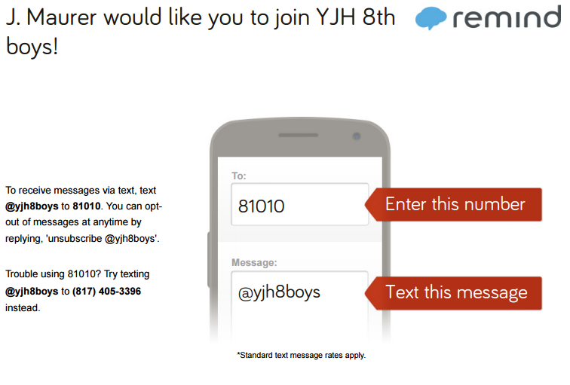
If you have any questions, please contact Coach Maurer at (682) 867-3400 or jmaurer@aisd.net.
Rank One Sports

