2015-2016 YOUNG LADY EAGLES

8th Grade Volleyball Schedule
“A” Games – 5:30PM / “B” Games – 6:30PM
NON-ZONE
DATE | OPPONENT | LOCATION
Wed. 9/16 | Gunn | Gunn
Wed. 9/23 | Barnett | Young
Sat. 9/30 | Boles | Martin H.S. (A)
Wed. 10/7 | Carter | Young

ZONE PLAY
DATE | OPPONENT | LOCATION
Fri.-Sat.  10/9-10 | **Tournament – A/B LEVEL**  (Ousley, Nichols, Shack, Young, Gunn) | Ousley
Wed. 10/14 | Nichols | Nichols
Wed. 10/21 | Workman | Workman
Wed. 10/28 | Ousley | Young
Wed. 11/4 | Shack | Shack
Fri.-Sat.  11/6-7 9:30AM | **Tournament – B LEVEL**  (Boles, Workman, Gunn, Young, Bailey) | Boles
Wed. 11/11 | Bailey | Young

CITY CHAMPIONSHIP – “A” Team
DATE | OPPONENT | LOCATION
Thurs. 11/12 –  Sat. 11/14 | TBD | TBD

Players are expected to stay for BOTH games. A bus will be provided for away games and players will be expected to ride the bus TO the game and back.
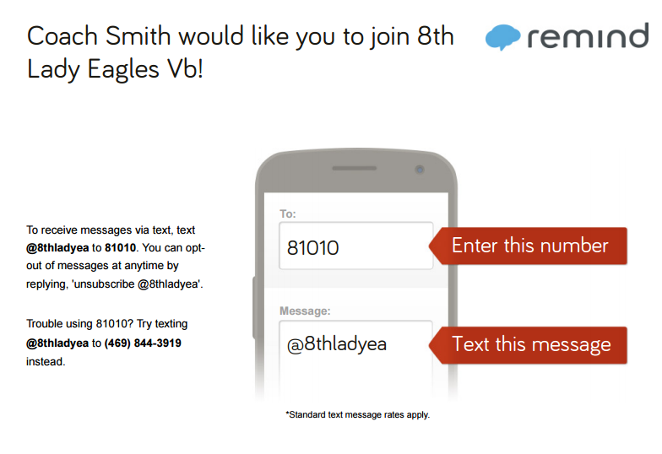
Buses will not be provided for Saturday tournaments which will begin at 9:30AM on Saturdays. (Subject to change). If you have any questions, contact coaches Starla Smith & Angela Davis at (682) 867-3400.
Rank One Sports

